Team Fallera:

Gibson, Joe;

Grossman, Molly;

Korpusik, Mandy;

Sato, Colby

**Experiment Design**

We will test one version of each feature on each user. We will time the user throughout their use of the app and ask them to think aloud as they use the app. We will also show the user the other variation and watch them go through it, but mostly look for significant errors. We expect them to be better the second time around, so we will disregard any increase in speed or ease of use.

We will ideally have four users that we test on so we can test each interface twice. We will test users on Monday and Thursday. Following the Monday test, we will make modifications suggested by the user in tests. After the Thursday test, we will show the user the old versions.

**Variations on Friends Directory**

**Put them in a different page.**

With the “My Friends’ Recipe Books” page and “My Recipe Book” pages gone, we had some more room on the homepage. We still needed a way to manage friends, so we thought of two ways to include a way of managing friends. On this version, the Friends list is on a separate page. They can be added and removed like in early versions of the design. Like in Skype, one can connect to other user accounts by simply entering the email address of the person. Clicking on the Friends button on the homepage opens up the Friends page.

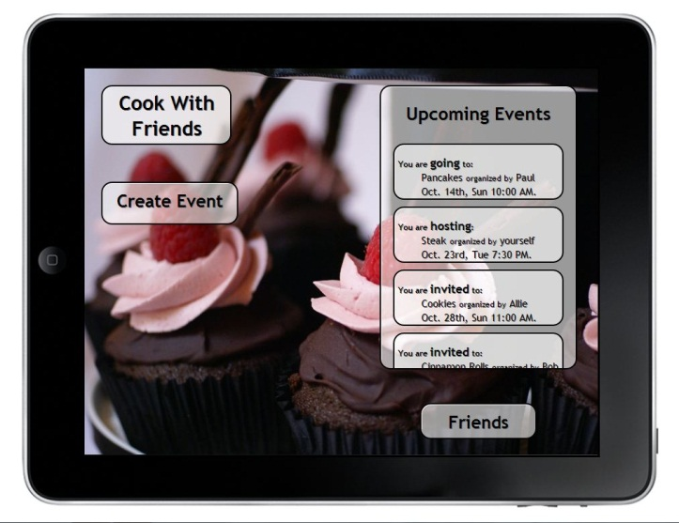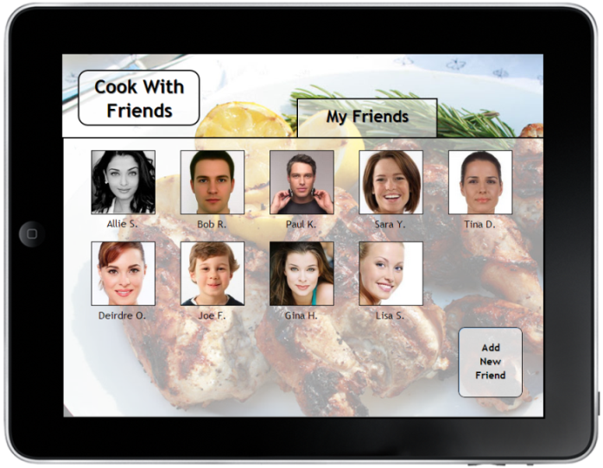

Figure The Homepage when Friends is a separate page.

Figure . The page that opens up to view friends and add a friend.

Our concern with the “Friends” collection being on a separate page is that this might take more time, and if the user is trying to add a friend while the user is planning an event, the user would need to exit out of the planning of an event, add the friend, and then restart the planning of an event.

**Put Friends in a tab with Upcoming Events**

Our other design is to have the friend’s feature in a tabbed box with the upcoming events list. The idea behind this is that keeping the friends on the home screen makes the interface more explorable.

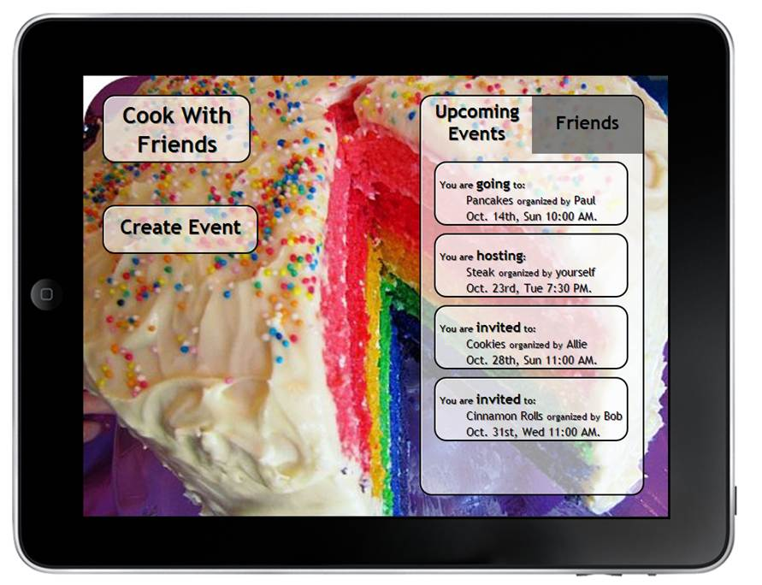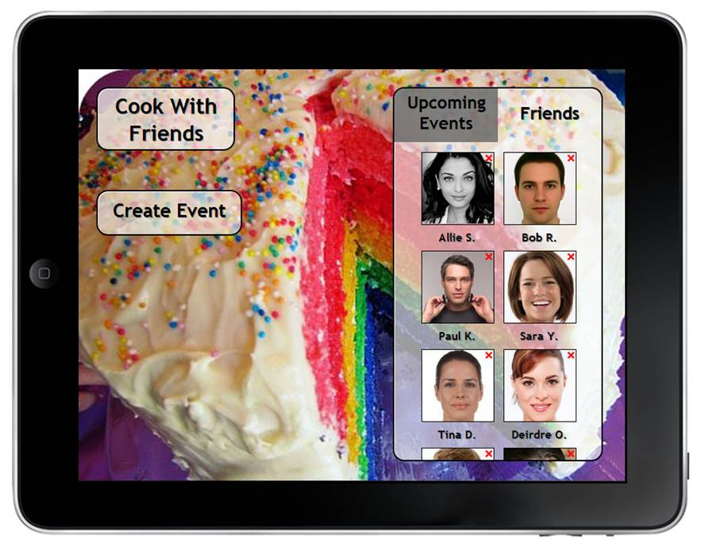

Figure . The view when the Upcoming Events tab is selected on the left, and the view when Friends is selected.

The potential problem with this is that with this reduced space for viewing friends, one must scroll down to see more than eight friends and to add a friend, whereas when the friends’ page is separate, the user can easily see up to 32 friends and add a friend, all without scrolling.

We have a solution for this that tests this interface with the add a friend button at the top of the friends list. This is valuable, because the user has more of a need to add friends than simply scroll through the people in the list.

**How we will know.**

The better solution will be the one that users do not get stuck on and are able to use more quickly. We will ask the user to add a friend and time how long that takes. We will watch the user interact with the interface and see if the user hesitates anywhere in the process.

**Variations on Creation of an event**

**Grouping Aspects of Creating an Event**

In this version, we grouped aspects of creating an event together. The Date and time of day selection are together with place, and the name of the event, what’s being made and the necessary ingredients are together.

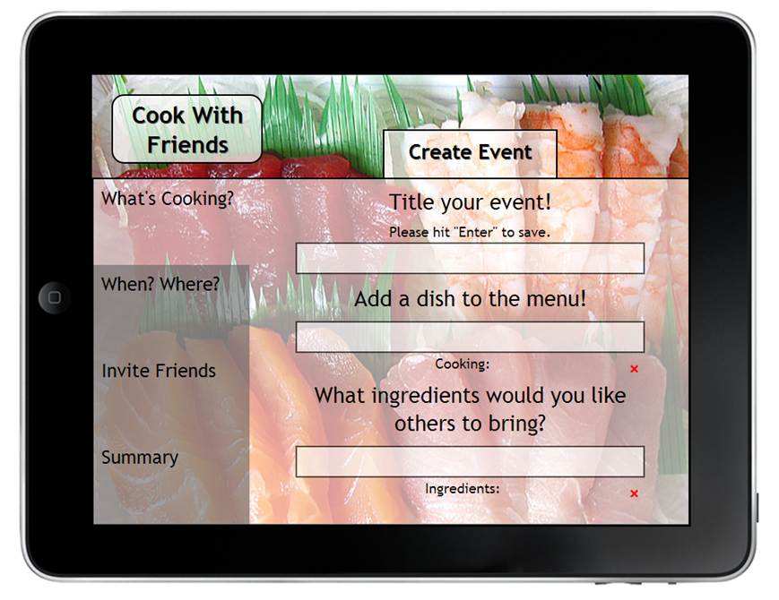

Figure . The different steps in organizing an event are grouped together to simplify the process.

**Separate Each Event Detail**

In our other format for the Create Event page, we have most aspects of creating an event in separate tabs.

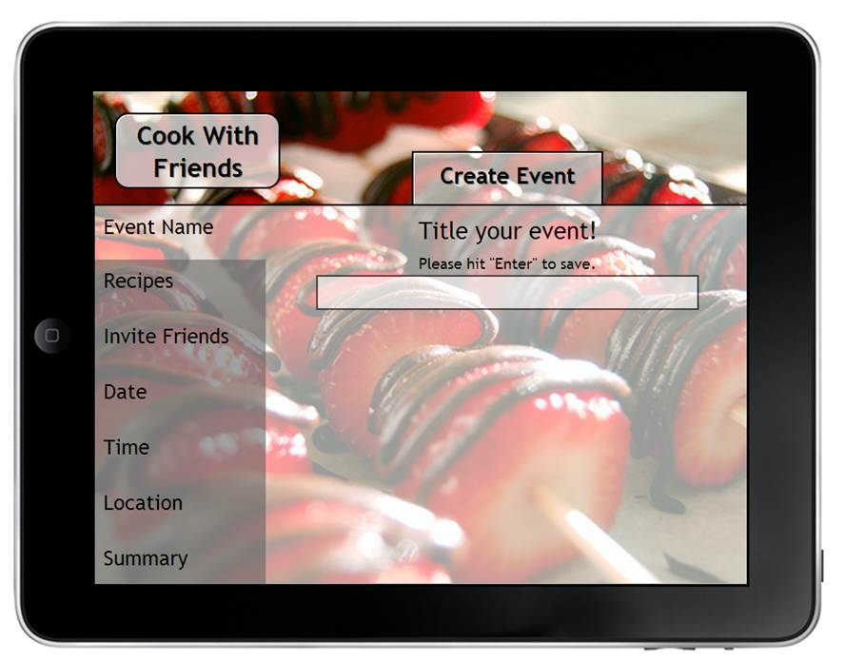

Figure . The different steps in organizing an event are separated so that on each page, there is ample room for detail.

Not every page has a lot of details, and in tests, the only page that ever became too cramped was the ingredients, recipe and event name page, so that page makes sense to be broken up further.

**How we will know.**

The better solution will be the one that users do not get stuck on and are able to use more quickly. We will ask the user to create an event and time how long that takes. We will watch the user interact with the interface and see if the user hesitates anywhere in the process.